**Table of Contents**

Introduction 3

CSP Framework 3

Scenario 1: 3

Scenario 2: 3

CSP Explanation 4

Comparison with other approach 4

Theoretical AI team 4

Data Visualisation 5

Rationale for Visualizations: 5

Conclusion 5

Bibliography 7

**List of Figures**

Figure 1, GUI Representation 4

**Tasks for Artificial Intelligence**

# **Introduction**

Ciara is faced with the task of selecting the best candidates for her new company, which specializes in AI-based logistic software for stores, while working under certain limitations. The purpose of the established CSP framework is to match employees according to their skill sets. Using Constraint Satisfaction Problem (CSP) frameworks, talking about CSP application, investigating different techniques, and illustrating the scenarios and solutions are the tasks involved (Brailsford, Potts and Smith, 1999).

# **CSP Framework**

## **Scenario 1:**

With her first budget, Ciara can only afford to recruit three workers. The purpose of the established CSP framework is to match employees according to their skill sets. To meet Ciara's employment demands, the problem consists of variables (roles), their corresponding value domains (people), and constraints. Constraints like the quantity of AI engineers, Python programmers, web designers, database administrators, and systems engineers required are specified in the code.

The final constraint guarantees that only six employees are chosen, and the lambda functions guarantee that the chosen employees fulfill the predetermined requirements. The getSolutions() method yields the solution to the problem.

The following personnel have been chosen for the positions:

* AI Engineer 1: Anita
* AI Engineer 2: Bruce
* Database Administrator: Jane
* Web designer: Anita
* Python programmer: Jane
* Systems engineer: Bruce

## **Scenario 2:**

In the second scenario, Ciara and Juan collaborate to raise more money and significantly change the positions that are needed. In light of this, the CSP framework is modified. Restrictions are changed to accommodate the additional AI Engineer and the revised hiring standards.

The selected workers in this case are:

* AI Engineer1: Anita
* AI Engineer2: Bruce
* AI Engineer3: Mary
* Database Administrator: Jane
* Web Designer: Anita
* Python Programmer1: Anita
* Python Programmer2: Bruce
* Systems Engineer: Mary

# **CSP Explanation**

When it comes to addressing problems, CSP is an effective paradigm, especially when there are significant limitations involved (Huang, 1996). The limitations take into consideration Ciara's financial constraints and guarantee that the chosen personnel fulfil the particular needs for each function. In order to identify workable solutions, the CSP framework used here makes it possible for us to methodically specify constraints, value domains, and variables. Its capacity to convey intricate dependencies and interactions between variables makes it special and appropriate for situations such as staff selection.

CSP is more declarative than traditional algorithmic solutions. CSP focuses on specifying the properties that the solution must satisfy, rather than explicitly defining the methods to get a solution. Contrary to typical algorithmic solutions, CSP offers a declarative issue expression method, enabling a more comprehensible and accessible depiction of the restrictions. Because of this, CSP is quite adaptable and useful for a variety of issues.

# **Comparison with other approach**

CSP is unique in that it can be used to represent and solve scenarios with constraints although there are other algorithms and tools available for handling optimization and assignment problems (Magazine and Magazine, 1992). The decision to select the Constraint Satisfaction Problem (CSP) framework over other methods stems from the unique benefits it provides for resolving the staff assignment issue within the framework of creating AI-driven logistics software. It strikes a good mix between expressiveness, usability, and scalability. One essential part of CSP is the Python Constraint Library, which offers pre-built constraints that improve code clarity and expedite problem description. The scalability of CSP guarantees effectiveness in managing varying team sizes and changing limitations, which is an essential feature in the ever-changing environment of staff assignments.

Furthermore, the readable and maintainable nature of CSP code makes the solution easier to access and understand, facilitating future changes and cooperation. Because of its expressive modelling, flexibility in responding to dynamic constraints, and general fit for scenarios with a lot of restrictions, such as personnel assignment in the context of AI development, CSP stands out as the best option among available algorithms and libraries.

# **Theoretical AI team**

In this hypothetical scenario, an AI development team consisting of Python programmers, AI engineers, web designers, database administrators, and systems engineers is entrusted with developing cutting-edge logistic software for retailers. For the sake of this report, we will assume that we are a member of this AI team.

## **Data Visualisation**

For the hiring circumstances and solutions to be successfully communicated, data visualization is essential. It allows users to interactively explore and manipulate alternate constraint scenarios. The given Python code builds an interactive graphical user interface (GUI) that lets users explore and comprehend the team composition using Tkinter and Matplotlib. It provided a Dropdown menu that enable users to modify role assignments, and visualizations respond dynamically.

## **Rationale for Visualizations:**

* The distribution of responsibilities and personnel assignments are displayed in Bar charts. When presenting categorical data, bar charts work well since they make it easy to compare role frequencies. This decision makes it easier to inform stakeholders of the team's makeup.
* Role assignments are shown visually in Network diagrams. Network diagrams help stakeholders understand the nuances of role assignments by providing a visual depiction of the links between entities. This choice is in line with the necessity of communicating not only the division of roles but also the particular dynamics within the team.

In order to provide stakeholders with clarity and interpretability, effective data communication principles inform the selection of colors, layouts, and chart formats.

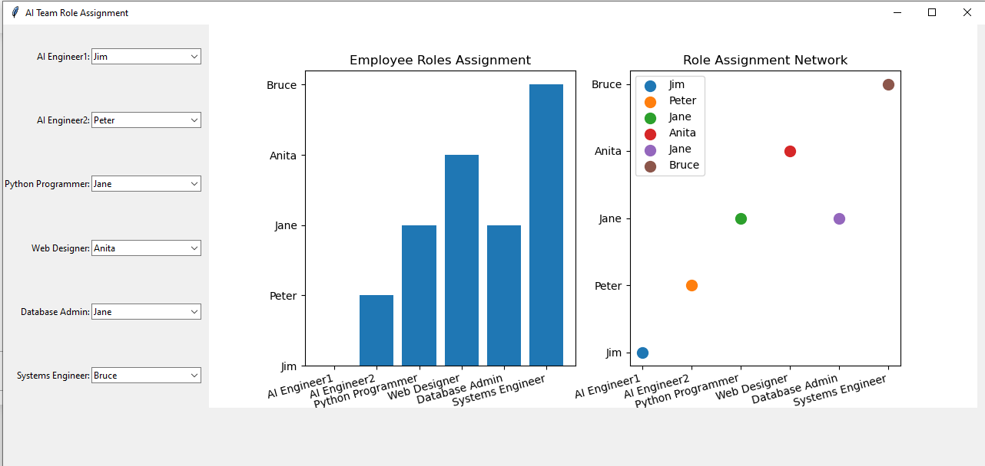

Figure 1, GUI Representation

# **Conclusion**

The report highlights the strategic use of visualizations in supporting decision-making processes within the AI development scenario, and it also demonstrates the team's dedication to effective communication by including a section on the theoretical AI team that highlights the practical application of data visualizations in a real-world context.

# **Bibliography**

Brailsford, S.C., Potts, C.N. and Smith, B.M. (1999) ‘Constraint satisfaction problems: Algorithms and applications’, *European Journal of Operational Research*, 119(3), pp. 557–581. Available at: https://doi.org/10.1016/S0377-2217(98)00364-6.

Huang, Y. (1996) ‘Using case-based techniques to enhance constraint satisfaction problem solving’, *Applied Artificial Intelligence*, 10(4), pp. 307–328. Available at: https://doi.org/10.1080/088395196118524.

Magazine, A.I. and Magazine, ; © Aaai) Ai (1992) ‘Algorithms for Constraint-Satisfaction Problems: A Survey’, *AI Magazine*, 13(1), pp. 32–32. Available at: https://doi.org/10.1609/AIMAG.V13I1.976.